

**LA GRANDEE INTERNATIONAL COLLEGE**

**Simalchaur, Pokhara Nepal**

A Project Proposal

On

**“Multi-Bakery”**

**Submitted to:**

Bachelor of Computer Application (BCA) Program

In partial fulfilment of the requirements for the degree of BCA under

Pokhara University

**Submitted by:**

|  |  |  |  |
| --- | --- | --- | --- |
| **Name:** | **Course** | **Semester** | **P.U. Registration Number** |
| Manish Shrestha | BCA | 8th | 2019-1-53-0120 |
| Kushal Kapri | BCA | 8th | 2019-1-53-0118 |
| Kshitij Gurung | BCA | 8th | 2019-1-53-0117 |

**Date:29/04/2024**

# ACKNOWLEDGEMENT

The satisfaction that accompanies after the successful completion of any task will be incomplete without mentioning the people whose ceaseless and relentless cooperation, constant guidance and encouragement made this project proposal report possible.

We are grateful to our project supervisor and faculty teacher **Mr Sunil Sapkota** and **BCA** coordinator **Mr Ramesh Chalise,** for the guidance, inspiration and constructive suggestions that helped us in the preparation of this project.

We are also appreciative among each other and have understood that teamwork, the designation of the task per the skillset one portrays, constant synchronisation and monitoring of progress and instilling new knowledge and skill is imperative for the success of any given work.

**DECLARATION FOR**

**“Multi-Bakery”**

# STUDENT’S DECLARATION

We hereby declare that we are the only authors of this work and that no sources other than the mentioned here have been used in this. We assure you that the work we present here is unique to ourselves and resemblances to another similar project are purely coincidental.

Manish Shrestha (2019-1-53-0120)

Kushal Kapri (2019-1-53-0118)

Kshitij Gurung (2019-1-53-0117)

Program: BCA, 8th Semester

Date: 29/04/2024

# SUPERVISOR’S DECLARATION

I hereby declare that the project entitled **“Multi-Bakery”** has been carried out under my direct supervision by Manish Shrestha (2019-1-53-0120), Kushal Kapri (2019-1-53-0118), Kshitij Gurung (2019-1-53-0117) during their Eight semester for the partial fulfilment of the requirements for the degree of **BCA (Bachelors of Computer Application)** program under **Pokhara University**

**_______________**

**Mr Sunil Sapkota**

(Project Supervisor)

Date: 29 April 2024

**TABLE OF CONTENTS**

ACKNOWLEDGEMENT ii

STUDENT’S DECLARATION iii

SUPERVISOR’S DECLARATION iv

1. INTRODUCTION 1

2. PROBLEM STATEMENT 2

3. OBJECTIVES 3

4. METHODOLOGY 4

5. PROJECT GANTT CHART/ TIMELINE CHART 5

6. DELIVERABLES 6

7. REFERENCES 7

# INTRODUCTION

In today's fast-paced baking industry, the need for adaptable solutions is more pressing than ever. Enter Multi-Bakery, a ground-breaking innovation poised to revolutionize the traditional baking landscape. As part of our project report, we delve into the multifaceted capabilities of multi-Bakery and its transformative impact on modern bakeries. Through meticulous research and analysis, we uncover how this versatile software enables bakeries to streamline operations, boost efficiency, and expand their product offerings seamlessly. From flexible batch adjustments to accommodating diverse recipes and optimizing production schedules, multi-Bakery emerges as a game-changer, providing unparalleled adaptability to meet the evolving demands of customers while upholding unwavering quality standards. Join us on this journey as we explore the disruptive potential of multi-Bakery in reshaping the future of baking.

# PROBLEM STATEMENT

* Fragmented Solutions: Existing bakery management software lacks integration, forcing businesses to use multiple disjointed tools for different functions.
* Limited Scalability: Small bakeries struggle to afford and effectively utilize complex ERP and POS systems designed for larger enterprises.
* Inefficient Operations: Manual processes and disparate systems lead to inefficiencies in inventory management, order processing, and customer engagement.
* Poor Customer Experience: Customers face challenges in discovering and ordering from multiple bakeries due to fragmented platforms and limited online presence.

# OBJECTIVES

* Develop an integrated ERP and POS platform specifically tailored for bakeries of all sizes.
* Provide scalable solutions that meet the needs and budget constraints of both small and large bakery businesses.
* Streamline bakery operations by automating processes such as inventory management, order processing, and accounting.
* Enhance customer experience by offering a user-friendly platform for discovering, ordering, and interacting with multiple bakeries seamlessly.

# METHODOLOGY

The Agile process model is a software development approach characterized by iterative development, breaking tasks into smaller iterations without extensive long-term planning. Project scope and requirements are established at the outset, with clear plans for the number, duration, and scope of each iteration. Each iteration typically lasts from one to four weeks, with the entire project divided into these manageable segments to mitigate risks and expedite delivery. Teams engage in a complete software development lifecycle within each iteration, encompassing planning, requirements analysis, design, coding, and testing, culminating in a demonstrated working product for the client.

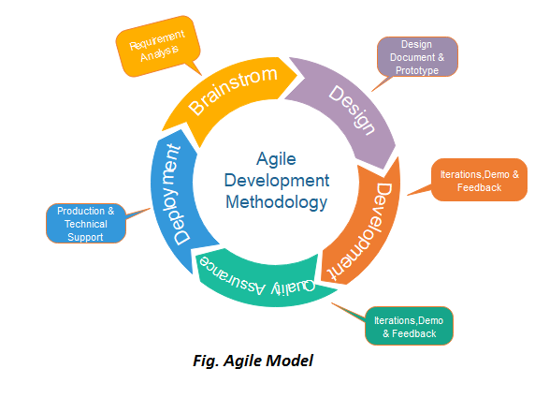

# PROJECT GANTT CHART/ TIMELINE CHART

It is a timeline of the project developed by Henry Gantt, also called project schedule chart.

In the vertical axis defines the tasks to be performed, on the vertical axis, and time intervals on the horizontal axis.

The Gantt chart contains the following information:

1. Start and End data of the project.
2. Completed project tasks, which are represented by a unique colored notation, can be shaded, or colored in gray color.
3. Duration of the tasks, how many days will it take to complete the tasks.



Figure 2: Gantt Chart

# DELIVERABLES

* Integrated bakery management software with ERP and POS functionality.
* Scalable platform catering to small and large bakery businesses.
* Automated processes for inventory management, order processing, and accounting.
* User-friendly interface for customers to discover and order from multiple bakeries.
* Technical support, documentation, and training for seamless implementation and operation.

# Conclusion

In conclusion, the development of an integrated bakery management software represents a significant step towards addressing the challenges faced by bakery businesses of all sizes. By providing a scalable platform with comprehensive ERP and POS functionality, our solution aims to streamline operations, enhance efficiency, and improve customer experience. With a focus on automation, scalability, and user-friendliness, we are confident that our software will empower bakery businesses to thrive in an increasingly competitive market landscape.

# REFERENCES

* <https://www.flexibake.com/>
* <https://www.shopcastiron.com/seller/resource/home-bakery-software>
* https://www.sagesoftware.co.in/blogs/bakery-erp/#:~:text=Bakery%20ERP%20helps%20manage%20the,%2C%20sales%2C%20and%20compliance%20management.